

OPERATION ACTIVE RESOLVE INTELLIGENCE REPORT

Russian and Chinese Live Fire Exercise outside Lebanon

# General Information

Russia and Chinese are planning a live fire exercise outside the coast of Lebanon on D9 at 1920Z-1950Z (1720G-1750G).

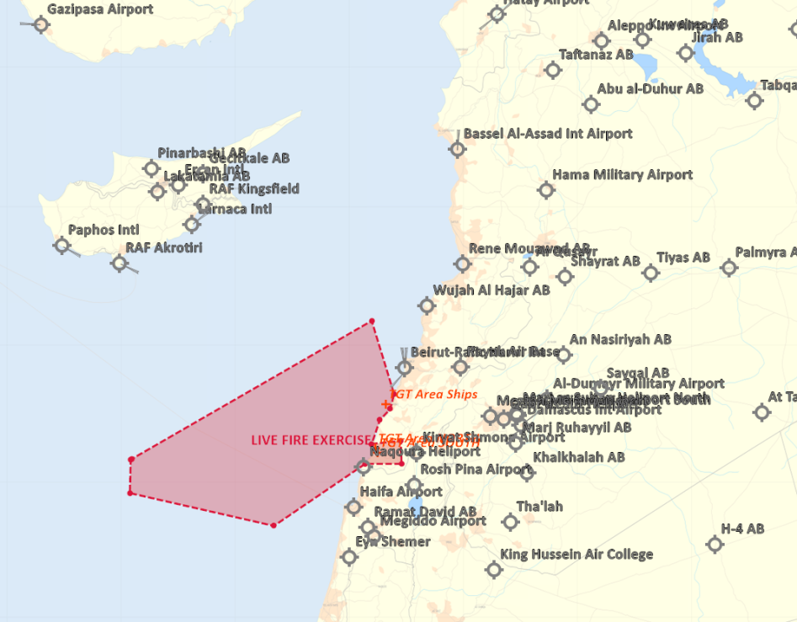

## Reported information

VID have credible reporting about a planning Russian and Chinese live fire exercise outside the coast of Lebanon and toward Lebanese ground targets on D9 somewhere in the timeframe 1920Z-1950Z (1720G-1750G). Lebanon have published a NOTAM with a danger area as shown in the map below (marked in red).

### Participants:

* Russian and Chinese strategic bombers
* Russian Airborne company (transported by 3x IL-76MD)
* Tu-22s
* SU-34
* TU-142
* Chinese drone

### Danger area

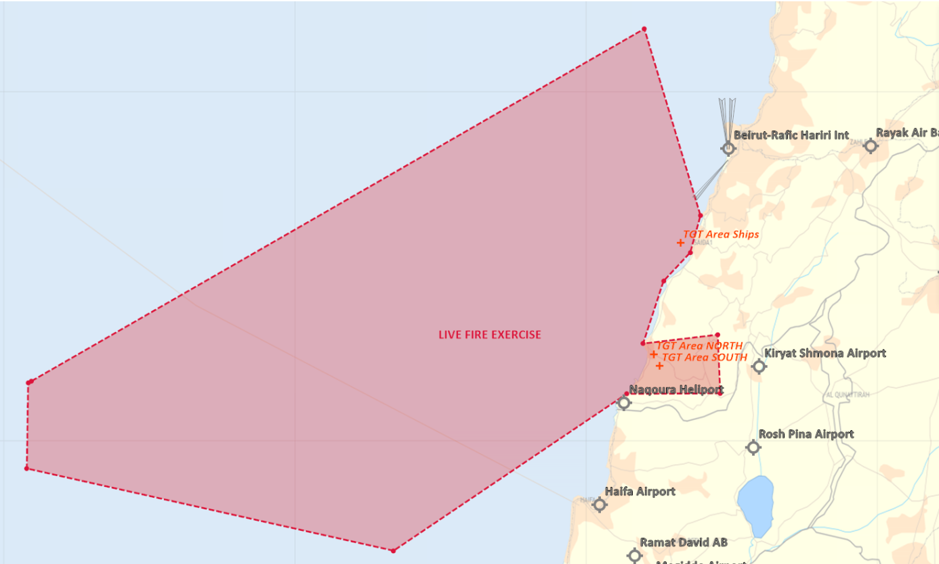

### Scheme of maneuver

VID do not have details of the scheme of maneuver but there are three target area. Target area north are a land based target consisting of several buildings. Target area south are a land based target consisting of several buildings. Target area ships are three ships in a static location just off the coast.

TGT area North: N 33 14.850 E 035 13.800

TGT area South: N 33 12.900 E 035 15.000

TGT area Ships: N 33 34.100 E 035 19.300

The exercise will LIKELY combine anti-ship and air-to-ground engagements followed by a air assault landing.

VID assess it as a opportunity to collect intelligence on Russian and or Chinese TTP for advanced complex attacks.

Attachement: [CombatFlite file with TGT area and danger area.](https://github.com/132nd-vWing/OPAR-Brief/raw/master/INTELLIGENCE/VID/OPAR%20VID%20INTREP%20Live%20Fire%20Exercise%20-%20Attachement.cf)